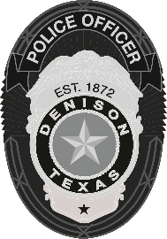 | Denison Police Department  108 W. Main Street, Denison, TX 75021  903-465-2422

NEWS RELEASE
Fatality Accident
Denison, Texas (June 25th, 2024) – On Tuesday, June 25th, 2024, at approximately 4:00 p.m., Denison Police responded to a motor vehicle accident at the intersection of 120 and FM 1417.

Upon arrival, officers determined a motorcycle driver had been traveling eastbound on 120 when a white Chevrolet pickup crossed northbound across 120 from 1417. The motorcycle impacted the pickup in the intersection. EMS arrived on the scene and pronounced the driver of the motorcycle deceased on the scene.

The driver of the white pickup remained on the scene and later voluntarily consented to a blood draw.

This investigation is ongoing. Names are being withheld until next of kin has been notified.

UPDATE: Next of kin has been notified. The motorcycle driver has been identified as 20-year-old, Dorian Saroka.

-30-

For more information, please contact:
Haley Banks
Media Relations Coordinator
Denison Police Department
903-465-2422 X 2339

