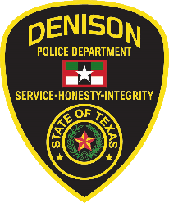  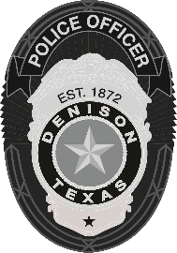 | Denison Police Department  108 W. Main Street, Denison, TX 75021  903-465-2422

NEWS RELEASE
Denison Police to Host Annual National Night Out
Denison, TX (September 29, 2022) – On Tuesday, October 4th citizens are invited to join the Denison Police Department for our third annual National Night Out (NNO) event. It will be held in Forest Park from 5:30pm-7:30pm.

National Night Out is a nationwide event sponsored by the National Association of Town Watch and co-sponsored by the Denison Police Department. NNO is designed to strengthen neighborhood spirit and police-community partnerships.

“National Night Out is one of our biggest events of the year. It is a time for our community to come together and celebrate the great relationships we have worked to cultivate over the years. It is a reminder to our city, that we as a police department are here to help each one of you,” said DPD Police Chief Mike Gudgel, “we are excited to celebrate this special evening with all of you!”

This event is free for all who attend. It will include:

- Bounce House
- Inflatable Obstacle Course
- Velcro Wall
- Touch-a-Truck
- Free hotdogs/water – Sponsored by Simmons Bank & First United Bank
- Officer Echo and Officer Buchanan’s K9 demonstrations
- CareFlight Helicopter Landing (if they are not out on a call)
- Live radio broadcast from Zac Grantham

The Denison Police Department, along with other vendors, will have free handouts for those who attend.

To learn more about National Night Out visit: https://natw.org/

-30-

For more information, please contact:
Emily Agans
Communication and Media Manager
Denison Police Department
903-465-2422 X 2339

