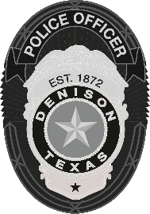 | Denison Police Department  108 W. Main Street, Denison, TX 75021  903-465-2422

NEWS RELEASE
Critical Vehicle Collision
Denison, TX (January 4, 2025) – On January 3, 2025, at approximately 2:00 p.m., Denison Police responded to a 911 call reporting a motor vehicle collision with injuries at the intersection of South Eisenhower Parkway and West Coffin Street.
Upon arrival, officers determined that a red Ford truck traveling southbound on South Eisenhower Parkway disregarded a red light. A silver Jeep traveling eastbound on West Coffin Street was attempting to turn south when the Ford truck collided with the driver’s side of the Jeep, causing significant damage and serious bodily injuries to both the driver and a juvenile passenger.
The driver of the Jeep sustained critical injuries and was transported to a local hospital before being airlifted to a Dallas area hospital due to the severity of her condition. The juvenile passenger sustained non-life-threatening injuries and was also transported to a local hospital.
The driver of the Jeep remains in critical condition at this time.
The driver of the Ford truck was taken to a local hospital for a blood draw as part of the ongoing investigation.
-30-

For more information, please contact:
Haley Banks
Public Information Officer for the Denison Police Department
Work Number: 903-465-2422 X 2339
Work Cell: 903-647-7802

