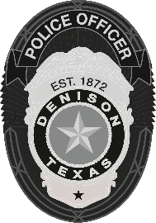 | Denison Police Department  108 W. Main Street, Denison, TX 75021  903-465-2422

NEWS RELEASE
Major Vehicle Accident on Hwy 75 Near Crawford
Denison, TX (February 13, 2025) – At approximately 8:00 a.m. this morning, Denison Police responded to a major vehicle accident on Highway 75 northbound near Crawford Street Road.
Initial investigations determined that a grey Honda minivan was traveling southbound when it left the roadway, crossed the median, and entered northbound traffic. The minivan clipped a Ford Bronco, causing it to spin off the highway before colliding with a black Dodge Ram pickup.
The driver of the Bronco sustained minor injuries and was alert at the scene. The driver of the Dodge was transported to a local hospital with non-life-threatening injuries. Tragically, the driver of the minivan was pronounced deceased at the scene. The deceased’s identity is being held until the next of kin is notified.
We ask the community to keep the family affected by this tragedy in their thoughts during this difficult time. This incident remains under investigation, and further updates will be provided as necessary.
-30-

For more information, please contact:
Haley Banks
Public Information Officer for the Denison Police Department
Work Number: 903-465-2422 X 2339
Work Cell: 903-647-7802

